Supplementary Experimental Report on Monocular Visual Depth Estimation

Comparative Experiment on Depth Channel Initialization Strategies

Experimental Purpose
This experiment aims to verify the impact of initializing the newly added depth input channel with the weights of different RGB channels from the pre-trained ResNet-18 model on the training convergence speed and final regression accuracy of the model under the SCR_R4Net network architecture.

Experimental Design
To achieve the above purpose, we designed a controlled experiment based on the constructed IBTD dataset. The main network architecture, hyperparameters (batch size of 16, initial learning rate of 1e-4, loss function as Mean Squared Error (MSE)), and number of training epochs were kept completely consistent. The only variable was the initialization strategy of the depth channel in the first convolutional layer of SCR_R4Net: the first group copied the convolution kernel weights of the red channel in the pre-trained ResNet-18, the second group copied the green channel weights, and the third group copied the blue channel weights. The evaluation metrics mainly included the regression accuracy (Mean Absolute Error (MAE) and Mean Squared Error (MSE)) on the validation set, as well as the key training efficiency indicator—the minimum number of training epochs required for the validation set loss to stabilize.

Experimental Results
Table Performance Comparison of Depth Channel Initialization Strategies
Table Performance Comparison of Depth Channel Initialization Strategies
Initialization Method | MSE | Convergence | Epochs
R channel | 0.0083 | 0.105 | 37
G channel | 0.0085 | 0.112 | 82
B channel | 0.0079 | 0.121 | 77
The experiment obtained clear quantitative results. As shown in the table, the model initialized with red channel weights achieved an MAE of 0.105 millimeters on the validation set. The most convincing finding lies in its convergence speed: the model reached a stable state in only 37 training epochs. In contrast, the models initialized with green and blue channels had similar final regression accuracy (MAE of 0.112 mm and 0.121 mm respectively) to the red-initialized model, but their convergence speeds were significantly slower, requiring 82 and 77 epochs respectively to achieve a similar stable state.

Analysis and Conclusion
Comprehensive analysis of the experimental results shows that although the three initialization strategies can achieve similar final model regression accuracy, initializing with red channel weights improves training efficiency, reducing the convergence period by more than half. This phenomenon may be due to the more stable or significant feature response of the metal surface of screws in the red channel during imaging in industrial scenarios, enabling the network to quickly establish an effective correlation between RGB appearance and depth information. Therefore, this experiment empirically confirms the superiority of the current initialization strategy, which is mainly based on considerations of training efficiency and deployment convenience in engineering practice, providing a solid basis for network design.
Signature | 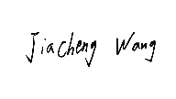

Model Robustness Verification Experiment (Multi-Interference Scenarios)

Experimental Purpose
This experiment aims to systematically evaluate the performance stability of the proposed screw tightness detection method under simulated complex real industrial environments. By simulating various common interferences such as illumination changes, oil contamination, and occlusion, the degree of performance degradation of the model is quantitatively analyzed, thereby clarifying the effectiveness and reliability boundaries of the method in practical deployment.

Experimental Design
To comprehensively evaluate robustness, we constructed an extended validation dataset. On the basis of the standard test environment, this dataset introduced six typical industrial on-site interferences: uneven illumination, painting on the screw or background surface, oil contamination, high-reflectivity background plate, and partial occlusion of the screw head (20% area and 50% area). Each interference condition contained 24 carefully collected images, and the true screw-surface distance was synchronously recorded using a high-precision laser rangefinder as the ground truth. The Mean Absolute Error was adopted as the core evaluation indicator, and a novel "performance retention rate" was defined to quantify the model's anti-interference ability. Its calculation formula is $P_{r}=(1-\frac{MAE_{dist}-MAE_{norm}}{MAE_{norm}})×100\%$, where $MAE_{norm}$ is the baseline performance.

Experimental Results
Table Robustness Verification Results Under Different Industrial Interference Conditions
Table Robustness Verification Results Under Different Industrial Interference Conditions
Interference Condition | Mean Absolute Error (MAE, mm) | Performance Retention Rate (%)
Normal Condition (Baseline) | 0.277 | 100.0
Illumination Variation | 0.314 | 86.8
Surface Coating | 0.302 | 91.1
Oil Contamination | 0.360 | 70.2
Highly Reflective Surface | 0.253 | 108.1
Partial Occlusion (20% Area) | 0.301 | 91.4
Partial Occlusion (50% Area) | 0.531 | 67.1

Under standard interference-free conditions, the model's Mean Absolute Error was 0.277 millimeters. When facing various interferences, the model showed differentiated robustness. For illumination changes, surface coating, and mild (20%) occlusion, the performance retention rates reached 86.8%, 91.1%, and 91.4% respectively, indicating that the model has good tolerance to these common changes. Notably, on high-reflectivity surfaces, the model's performance retention rate exceeded 100% (MAE of 0.253 mm) because the reflective texture provided additional feature clues. However, under extreme conditions of oil contamination and severe (50%) occlusion, the performance degradation was relatively obvious, with performance retention rates of 70.2% and 67.1% respectively, but it still remained within the usable range.

Analysis and Conclusion
This experiment quantitatively reveals the applicability of the proposed method in non-ideal industrial environments. The results show that the method has strong adaptability to illumination fluctuations, changes in surface physical coatings, and slight occlusion, which is mainly attributed to the design combining depth difference features and attention mechanism, reducing the dependence on single RGB appearance features. Performance degradation mainly occurs when the key visual information of the target (such as contour) is severely damaged (severe occlusion) or the physical height of the target is indirectly changed by contaminants (oil adhesion). This clearly delineates the boundary for the reliable operation of the model, providing clear guidance for the installation environment requirements of the visual system in industrial deployment (such as avoiding severe occlusion and keeping the lens clean).
Signature

Qualitative Analysis of Failure Cases and Classification Confusion Research

Experimental Purpose
This experiment aims to gain an in-depth understanding of the failure modes and inherent causes of the model through qualitative analysis of its misprediction cases. At the same time, by constructing a confusion matrix for classification tasks, the main confusions of the model in distinguishing different tightness levels are systematically revealed, thereby clarifying the challenges faced by the current method in terms of perception limits.

Experimental Design
Samples with significant prediction errors were selected from the robustness test and standard test sets for visual diagnostic analysis. We systematically attributed several types of typical failure scenarios. In addition, on the complete test set, a confusion matrix was generated for the classification results of four screw tightness states (OK, L1, L2, L3) to statistically reveal the laws of misclassification. The analysis not only focuses on the overall accuracy but also emphasizes whether errors are concentrated between specific categories.

Experimental Results
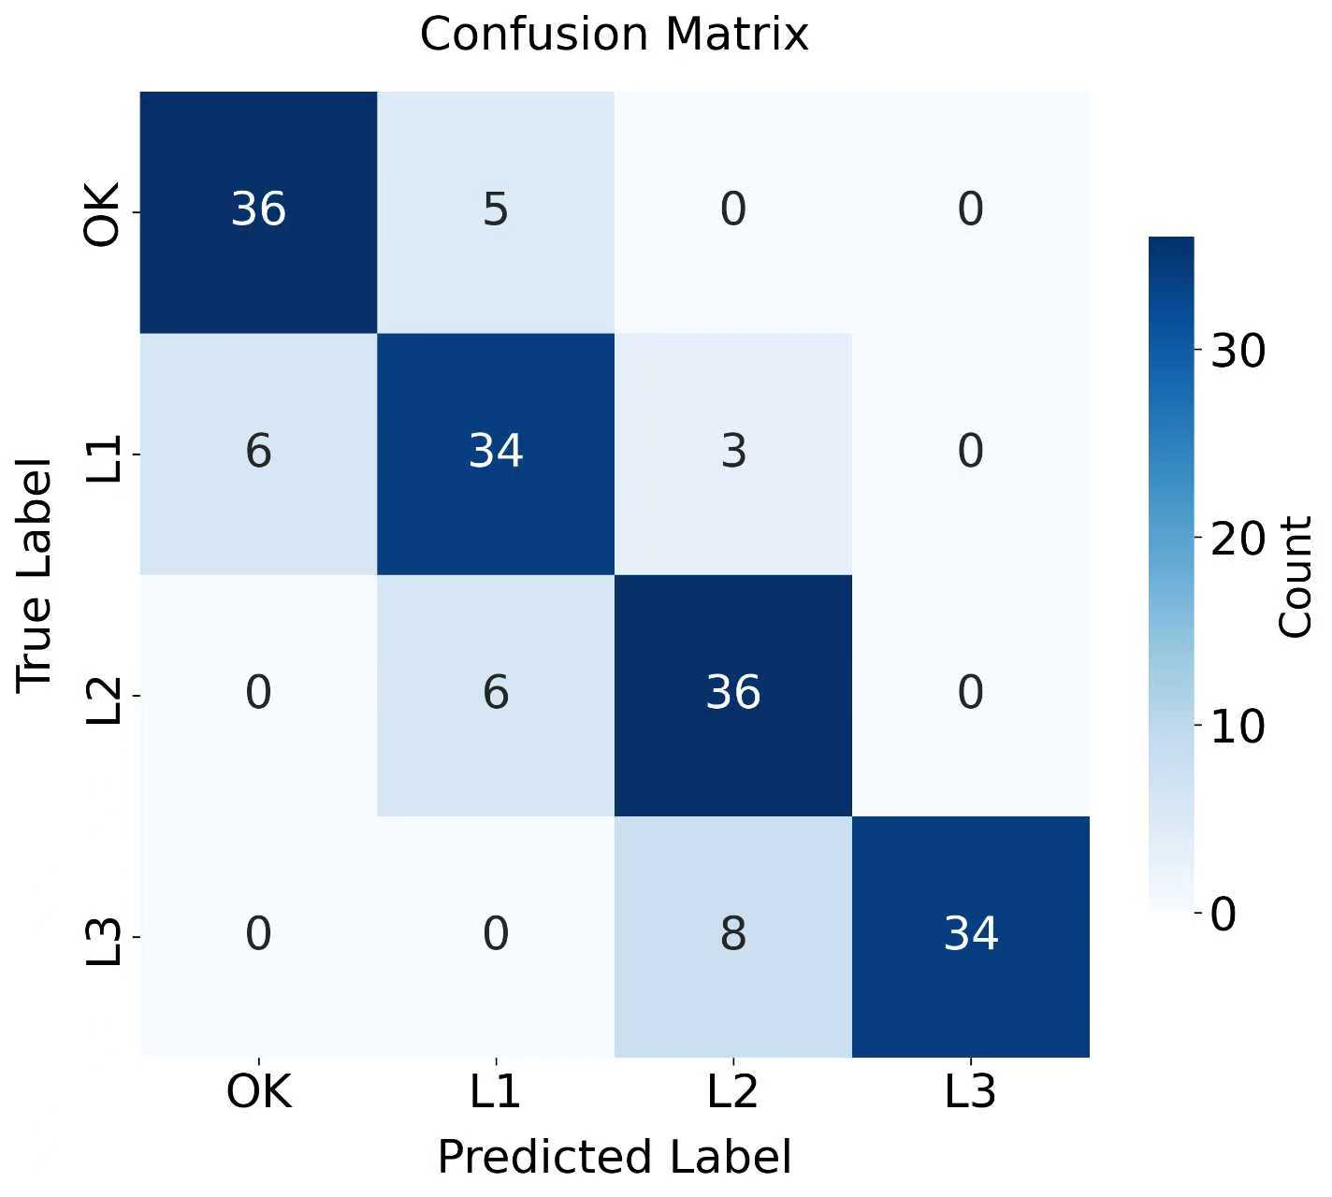
Qualitative analysis identified three main failure modes. The first is severe geometric occlusion (area greater than 50%), which leads to the loss of screw contour information, resulting in significant deviations in both depth estimation and subsequent feature extraction. The second is an extreme specular reflection background, which causes the depth values of the background area to be systematically underestimated, thereby distorting the "screw-background" depth difference as the core discriminant basis. The third is the presence of attachments (such as dried oil stains) on the surface of the screw head, which essentially changes the physical height of the measured part, leading to inconsistency between the prediction result and the true screw tightening state. The quantitative results of the confusion matrix are consistent with the qualitative analysis, showing that the classification errors of the model mostly occur between adjacent tightness levels, such as "OK" and "L1", "L1" and "L2", with an average inter-class confusion rate of about 20%.

Analysis and Conclusion
Comprehensive qualitative and quantitative analysis shows that the performance boundary of the model is closely related to the accessibility and distinguishability of physical information. When the key geometric or appearance information of the target is obscured by occlusion or reflection, or its physical state is accidentally changed, the model performance will degrade. More importantly, the confusion matrix indicates that distinguishing small height differences at the sub-millimeter level is the fundamental difficulty of the current task, which is also the reason why errors are mainly concentrated in adjacent categories. The conclusion of this experiment points out that future work can improve the distinguishability of adjacent states by enhancing the model's ability to perceive local small deformations or introducing temporal information. At the same time, it emphasizes the importance of ensuring that the detected target area is clear and free of attachments in practical applications.
Signature

Depth Estimation Uncertainty and Error Propagation Analysis Experiment

Experimental Purpose
This experiment aims to quantitatively evaluate the errors introduced by the upstream pre-trained depth estimation model (Depth Anything V2) in this specific task, systematically analyze how these errors propagate through the subsequent processing chain, and finally clarify the error suppression mechanism that enables the entire system to achieve high-precision prediction without fine-tuning the depth model.

Experimental Design
The experiment was divided into three stages. First, the source evaluation of depth estimation errors was performed: using the sparse high-precision ground truth points obtained by the laser rangefinder, the relative depth maps output by Depth Anything V2 on the test set were scale-aligned, and then the pixel-level estimation errors in the screw head area and the surrounding annular background area were calculated. Second, the final output error was evaluated: the absolute error of the screw-surface distance predicted by the SCR_R4Net network on the entire test set was counted. Finally, error propagation analysis was conducted: by comparing the spatial distribution and statistical characteristics of the depth estimation error and the final regression error, the offset effect of the proposed "normalized depth difference feature" on errors and the error suppression ability of the multi-modal fusion of the SCR_R4Net network were explored.

Experimental Results
Table Statistical Analysis of Depth Estimation Errors (unit: mm)
Statistical Metric | Screw1 | Screw2 | Screw3 | Screw4
Mean Absolute Error (MAE) | 0.19 | 0.07 | 0.05 | 0.12
Error Standard Deviation (Std) | 0.10 | 0.05 | 0.03 | 0.06
95% Error Upper Bound* | 0.37 | 0.17 | 0.12 | 0.25
Table Screw-to-Surface Distance Prediction Error Statistics of Test Set (unit: mm)
Statistical Metric | Screw1 | Screw2 | Screw3 | Screw4
Mean Absolute Error (MAE) | 0.02 | 0.05 | 0.09 | 0.02
Error Standard Deviation (Std) | 0.05 | 0.05 | 0.06 | 0.04
95% Error Upper Bound* | 0.12 | 0.15 | 0.21 | 0.11
The statistical results of depth estimation errors show that the average absolute error of Depth Anything V2 for depth prediction of various screws ranges from 0.05 mm to 0.19 mm, the standard deviation of errors is small, and the 95% upper error bound is up to 0.37 mm. A key finding is that the errors of depth estimation in the screw area and its adjacent background area show a high degree of spatial positive correlation. In the final regression stage, the average absolute error of the screw-surface distance predicted by SCR_R4Net is further reduced, ranging from 0.02 mm to 0.09 mm, and its 95% upper error bound is up to 0.21 mm. The final prediction accuracy is better than or equivalent to the accuracy of the upstream depth estimation itself.

Analysis and Conclusion
This experiment reveals the inherent error suppression principle of the proposed framework. Although the general depth estimation model used has certain errors, these errors are systematic in space. By calculating the depth difference between the screw area and the background area, the common systematic deviations in both areas are effectively offset by subtraction, resulting in a more robust tightness-related feature. Subsequently, the SCR_R4Net network further corrects the remaining errors by fusing RGB appearance information with this depth difference feature. Therefore, the entire system forms a dual error suppression mechanism of "differential debiasing + fusion correction". This theoretically explains why sub-millimeter-level high-precision tightness state discrimination can be achieved without task-specific fine-tuning of the depth model, providing a solid foundation for the reliability of the method.
Signature

